Sharing from La Milpa, Honduras
April 30, 2023
Text: Acts 2:42-47
Psalm 23
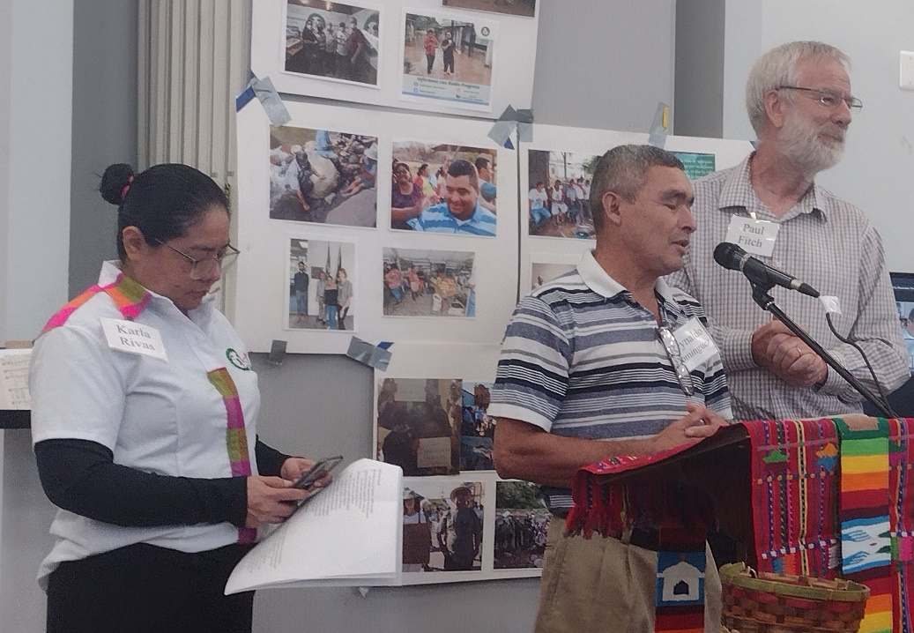
Introduction (Paul Fitch):
I am delighted that Karla Rivas and Reynaldo Dominguez are here with us visiting from Honduras, now nearing the end of a whirlwind tour of various cities in the US where they have shared from their struggle to create a better homeland for all, where no one is forced to leave to seek an uncertain future in this often-unwelcoming foreign land.
Karla Rivas is a journalist, editor, producer, and anchor for the Jesuit sponsored Radio Progreso Honduras, where she has worked for twenty-five years, producing critical analysis and reporting of the broad social and political context of her land. She is part of an incredible team of people who make up a truly excellent radio station and center for research, reflection, and communication in all of Central America. To do so entails levels of risk in a country unfriendly to such candid reporting. She is also coordinator of the Network with Migrants in Central America for Radio Progreso.
Reynaldo Dominguez is a small-scale farmer with a deep love for the land and for his community, Guapinol, which lies alongside the Guapinol River beneath mountains covered in lush tropical forest. He has also been a delegate of the word (Catholic lay leader) for 35 years. Since 2018 he has formed part of a local and regional fight to halt an iron ore mine run by one of the country’s wealthiest families, under a mining license irregularly approved by the government to operate in the heart of a national park. As several communities began protesting in an effort to halt the mine in the face of area rivers becoming so contaminated that they became useless for human and animal consumption, Reynaldo and twelve others were surprised, in 2019, to be suddenly hauled away and jailed, under trumped-up charges. With excellent lawyers and public, and international pressure, they were released two weeks later, after the judge declared that, “to defend water is not a crime.” (I was present there in the courtroom). However, eight others were later arrested and illegally imprisoned for thirty months under the same false charges. The threats continue, to the point that Reynaldo’s brother Aly Dominguez and Jairo Bonillo, another companion in the fight against the mine, were murdered, death-squad style, in January of 2023.
I want to mention that I have been to Honduras a number of times since the 2009 coup, and then after the country took a step towards democracy with the election of Xiomara Castro, Honduras’ first women president, after twelve years of dictatorship. What touched me and humbled me the most on our most recent visit to Honduras is how much they count on our solidarity and how much of an opportunity they present to us to yet enter into a positive relationship with the people of Honduras and do the right thing by them in our own country. I loved the expression by Sister Rosa Maria (who could not come, due to the death of a dear sister), that “the space of solidarity is one of standing upon holy ground, where we take off our sandals, one unto the other, to be both humbled and strengthened.”
I now pass the word on to Karla and Reynaldo.
Sermon:
Karla Rivas: Thank you very much. Good morning once again. In the reading today from Acts, the phrase about sharing of bread stands out for me. It made me think, “well, what is it that we have which can give to others?” Right away many examples came to mind of instances of sharing, connected with people who are migrating: Open homes, open churches, open shelters. They share coats, share food, but also share hope. This shared solidarity with migrant persons reminded me very clearly that we are sons and daughters of one God. And these people who are forced to flee from our countries are also seeking to share their lives, and in many instances also to save lives. It is important that you know that many of the factors that obligate people, men, women, entire families, have at heart the inequality that they cannot build up their lives in their own land.
In 2018, when there was a caravan, the press called it “a migratory exodus.” In fact, it was an exodus, just like in that time when the People of God left in search of the promised land. In Mexico I had the opportunity to speak with a whole lot of migrants in that caravan, and to find how, even in those moments of cold, of hunger, of uncertainty, the people organized themselves to share bread, and food. I especially remember all the women who carried children, often infants in their arms, demanding of the men to take into account that they were traveling with children, and to seek the safest route, and not necessarily the shortest one. The men, and the youth, listened to the needs of the women and the children and, for this reason, the way through Mexico was longer. It was there that I discovered how community building happens, as they attended to the needs when they share the same dream. In that moment the dream was to arrive to the United States, to seek a better opportunity for their lives.
I also want to mention a program that we are developing in Honduras, and we call “La Milpa” [the cornfield]. It is a physical project to cultivate food, to cultivate and build community, but it is also developing the organization of the community. La Milpa means to grow food and build community, but it also means to build opportunities in our own country so that the people are not forced to migrate. La Milpa also has a political element because it calls us to be mindful of our relationship with nature, of our responsibility to take care of the land, to thus nourish ourselves from the land. La Milpa also reminds us that land in Honduras is in the hands of very few people, while many people are hungry. We believe that La Milpa is an exercise in building the future in our own country, and if we carry out this project, we are sure that this is a mission in which God accompanies us. Thank you very much.
Reynaldo Dominguez: Good morning. We were already here once before sharing in this place. And you will say that the handsome guy from Guapinol has returned. An embrace to those sisters and brothers connected on Zoom. I will only take a short time. I said, when I introduced myself, that I am a social fighter, and I am a fighter defending the rivers and the Botaderas Mountains, Carlos Escaleras National Park. We are in the fight because the rivers are in danger. Water is life, and we are defending this generation, these valleys. We adults can understand when they say, “There is no water” but the children cry when there is no water; they don’t understand why. So we must speak for them.
When we began in this fight, we began it precisely with this Psalm 23, saying to the Lord, “You are our shepherd, we shall lack nothing. Hallelujah!” And we will continue in this fight, with our sadness and our joy, but we continue onward, because the Lord is our strength. Even though we must suffer, as I am suffering and my family is suffering for the death of Aly and Jairo, the rivers and the mountains need them. And I know that they are there now, in those green pastures that this Psalm offers them. That is our hope.
In the second reading, in the book of Acts, it tells us that we must be united, and this community, of the church, I see as truly united. My companion Karla spoke of the project of La Milpa, and you have sowed in this cornfield. The financial support you have provided to La Milpa is of great value. La Milpa is diversity; it comes from over there, from here, with a diversity of ways of thinking, but it comes from a united community. This is how La Milpa is, with plantain, yucca, squash, many things! This concept relates to what you do: share, like the first communities.
I want to end by saying this: it is not necessary to sell properties, but rather to share from them. This is what you do. Blessings to all of you, women, men, children. Thank you very much (the only thing I can say in English).

